**Draw the activity diagram for the specified Case Study.**

Table of Contents

1.) Case Study: 2

1.1) Introduction 2

1.2) The Challenge 2

2.) The Solution: Expense Analyzer App 3

2.1) Voice Recognition: 3

2.2) Geographical Limit Enforcement: 3

2.3) Financial Goal Fulfilment: 3

3.) ACTIVITY DIAGRAM 4

4.) Use case Diagram 6

4.1) Create Account Successfully 6

5.) Results and Benefits 7

4.1) Effortless Expense Tracking: 7

4.2) Improved Financial Awareness: 7

4.3) Promotion of Responsible Spending: 7

4.4) Savings and Goal Attainment: 7

6.) Real-World Applications 8

5.1) Individual Financial Management: 8

5.2) Family Budgeting: 8

5.3) Business Expenses: 8

7.) Conclusion 9

**Creating a case study for your Expense Analyzer App can help illustrate its real-world applications and benefits. Here's a sample case study:**

1. Case Study:

* Optimizing Personal Finance with the Expense Analyzer App

## Introduction

In today's fast-paced world, managing personal finances has become increasingly challenging. Budgeting, tracking expenses, and adhering to financial goals can be cumbersome and prone to errors. Anmol Goyal, a forward-thinking MCA student, recognized these challenges and embarked on a journey to simplify personal finance management. He developed the Expense Analyzer App, a groundbreaking solution that leverages voice recognition and geographical limit enforcement to revolutionize the way individuals manage their expenses.

## The Challenge

Traditional expense tracking methods often require manual data entry, which can be time-consuming and error-prone. Additionally, many individuals struggle to stay within their budget limits, leading to overspending and financial stress. Anmol Goyal aimed to address these challenges and create a user-friendly tool that would empower individuals to take control of their finances.

## The Solution: Expense Analyzer App

Anmol's innovative solution, the Expense Analyzer App, combines cutting-edge technology with user-centric design principles. The app offers the following key features:

2.1) Voice Recognition: Users can effortlessly input expenses by simply speaking them, eliminating the need for manual data entry. This hands-free approach enhances user convenience and reduces errors.

2.2) Geographical Limit Enforcement: The app utilizes GPS tracking to monitor users' expenses within predefined geographic areas. When expenses exceed set limits in a specific zone, the app sends immediate alerts, promoting responsible spending.

2.3) Financial Goal Fulfilment: When expenses fall below allocated limits, the app suggests optimal budget allocations to fulfill unmet financial needs or savings objectives, making financial planning accessible and actionable.

# 3.) ACTIVITY DIAGRAM

3.1.) For User Registration

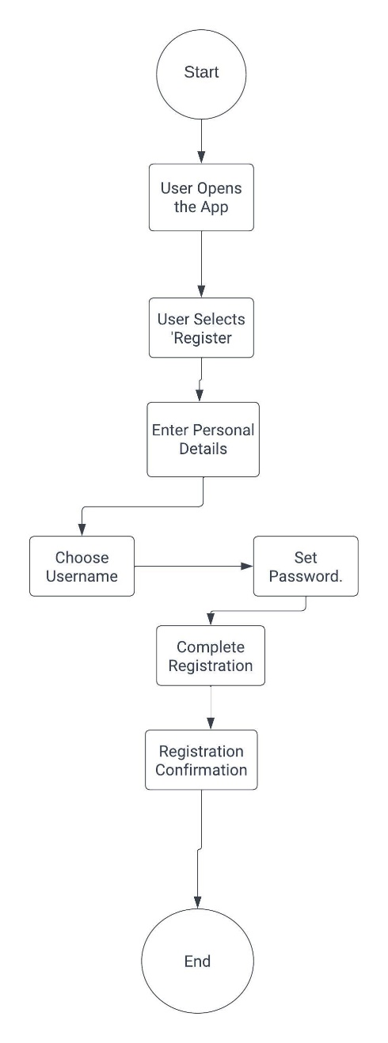

**Figure 1 Activity Diagram for User Registration**

3.2.) Mode Selection

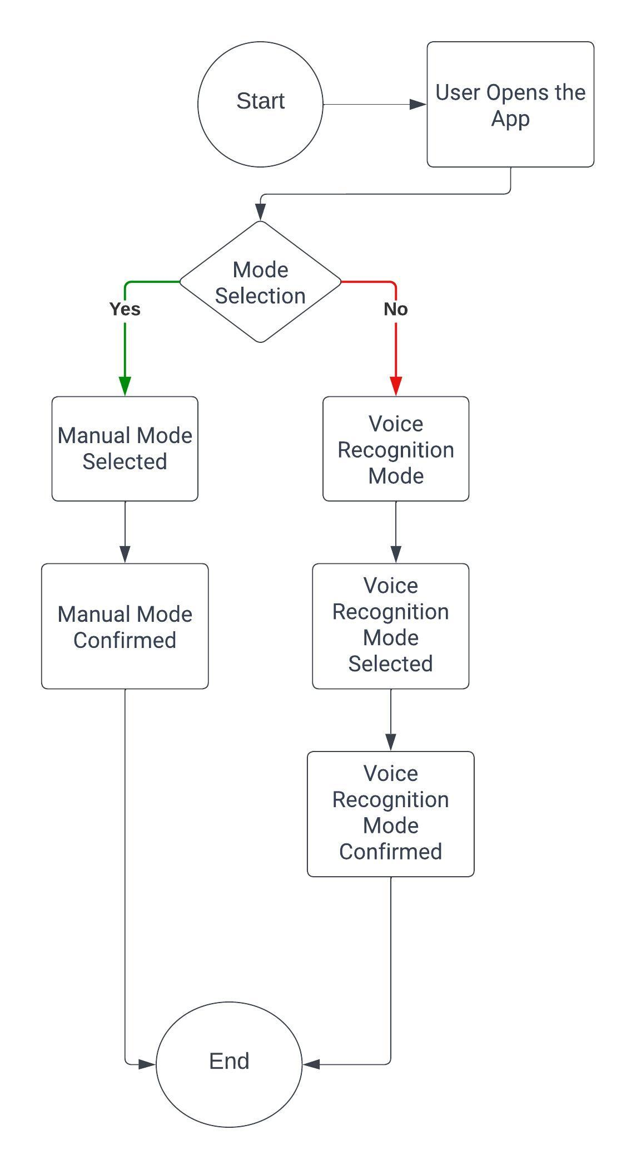

**Figure 2 Mode Selection after Opening App**

# Use case Diagram

## 4.1) Create Account Successfully

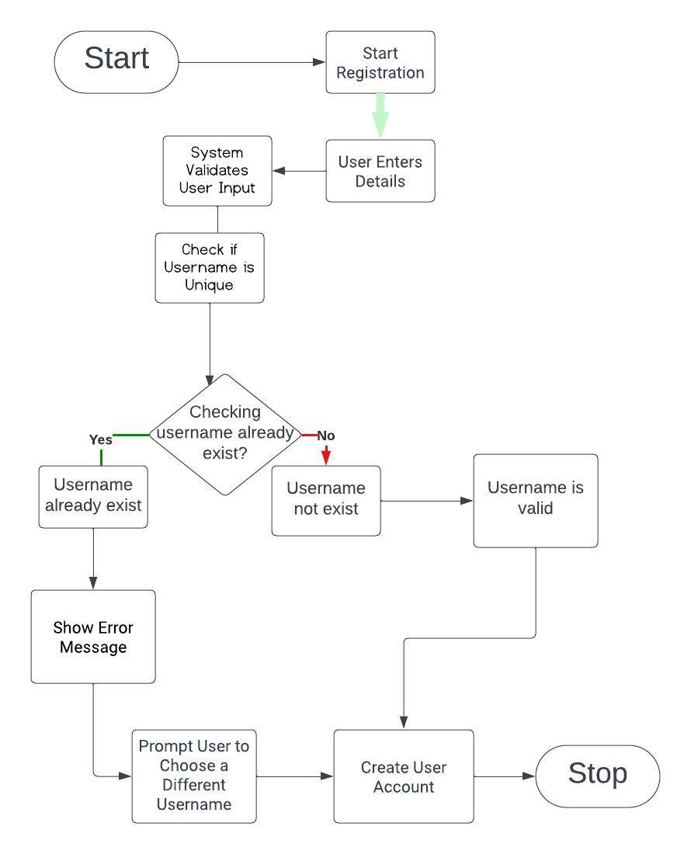

Figure 3 Created Account Sucesfully

### Results and Benefits

The Expense Analyzer App has yielded significant results and benefits for users:

4.1) Effortless Expense Tracking: Users can track their expenses effortlessly, thanks to voice recognition technology, saving time and reducing the burden of manual data entry.

4.2) Improved Financial Awareness: The app provides users with insights into their spending habits within different geographical areas, enhancing their understanding of their financial behavior.

4.3) Promotion of Responsible Spending: Geographical limit enforcement alerts users when they exceed spending limits, encouraging responsible financial behavior and reducing overspending.

4.4) Savings and Goal Attainment: The app empowers users to achieve their financial goals by suggesting optimal budget allocations when expenses are below set limits.

### Real-World Applications

The Expense Analyzer App has found applications in various real-world scenarios:

5.1) Individual Financial Management: Individuals use the app to gain control over their personal finances, reduce overspending, and achieve their savings goals.

5.2) Family Budgeting: Families benefit from the app by setting spending limits for various family members and tracking expenses within defined geographic areas.

5.3) Business Expenses: Small businesses use the app to monitor and control employee expenses during business trips or within specific regions.

# Conclusion

Anmol Goyal's Expense Analyzer App represents a significant leap forward in personal finance management. Its combination of voice recognition and geographical limit enforcement offers a unique and user-friendly solution to the challenges of budgeting and expense tracking. As individuals and businesses seek more efficient ways to manage their finances, the Expense Analyzer App is poised to make a lasting impact, promoting responsible spending and financial well-being.

Feel free to customize this case study to include specific details and outcomes related to your Expense Analyzer App.